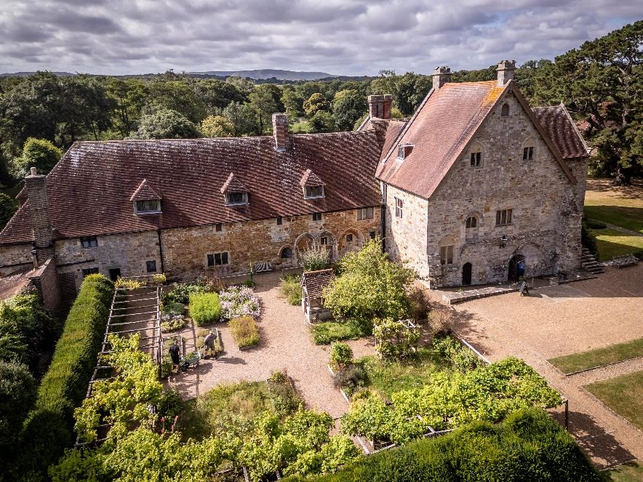

EXPRESSION OF INTEREST:

The Sussex Archaeological Society is a registered charity, established in 1846 and the UK’s oldest group of its kind. Sussex Past is the trading name for the society which owns and operates 10 Listed Buildings, 6 Scheduled Ancient Monuments, a registered park and garden. In the heart of the Sussex countryside is Michelham Priory House and Gardens. The property is registered for wedding ceremonies and is often used for events.

Sussex Past is issuing an expression of interest to existing food and beverage operators within East Sussex, to seek a partner to operate the café within Michelham Priory House and Gardens. Until recently the café was operated by Sussex Past and latterly by a third-party operator. Details of the previous operation can be shared as part of this process (on request).

Sussex Past would be happy to hear ideas from any operators that would be interested in operating the café and would welcome suggestions for any additional catering opportunities. This is an exciting opportunity to operate the café at Michelham Priory, serving both hot and cold food and drinks, including alcoholic and non-alcoholic beverages, from March to December.
Michelham Priory, with its rich history and beautiful surroundings, is a prime destination for visitors seeking a blend of culture and relaxation. We are looking to secure a partner in the cafe to contribute to enhancing the visitor experience by offering a high-quality café service that aligns with the Priory’s ethos.
We are looking for a team which is experienced in the hospitality sector, particularly in operating café environments within historical and cultural settings who are committed to championing local produce and suppliers. The café should provide a thoughtfully, considered selection of freshly prepared meals and beverages that cater to diverse tastes and dietary needs. The menu should include a variety of hot and cold options and visually appealing cakes and pastries. Championing Sussex wherever possible you should be ensuring sustainability and supporting the local economy.
The offer should also include an appealing range of alcoholic and non-alcoholic drinks, including fine wines, beers, and refreshing non-alcoholic alternatives, all served with a focus on quality and customer satisfaction.
Our vision is for the café is to create a welcoming and enjoyable environment, relaxed, informal and balancing contemporary with the traditional. It should complement the serene and historical ambiance of Michelham Priory. We expect that our partner organisation would aim to provide exceptional service to both regular visitors and members, ensuring that every guest has a memorable experience.
Michelham Priory hosts a number of weddings and events and ideally the café partner will be able to offer additional catering services during the busy event season.

On average Michelham Priory receives around 20,000 visitors per year.

If you would like to find out more and would like to arrange a site visit then please contact Annie Wills, Head of Commercial Activities.

Email – anniewills@sussexpast.co.uk or 01273 486290.

Purpose of this document:
- To determine the establishment of a cafe operation at Michelham Priory
- To enable a fair and equal assessment of bids where there is more than one interested party.
- Act as a base document against which the viability of the proposal or proposals can be assessed.
- Ensure any proposal is in line with the Strategic Action Plan

Please return your form to anniewills@sussexpast.co.uk no later than
12th January 2025

Proposal

Location: |  |  | Michelham Priory Café  Upper Dicker
Organisation
Name
Position in Organisation:
Address:
Telephone:
Email:
Type of organisation
Please note that the boxes below will automatically expand if needed
INTRODUCTION
- EXECUTIVE SUMMARY

Please outline the proposed use of the space – to include output(s) and tangible benefits expected from the proposal. Please consider the following when outlining your proposal:

- Site Use – please demonstrate the food and drink offer, preferred opening times.
- Length of lease/licence required.
- Deliverability
- Commencement

2. PROPOSAL DETAILS

Please provide brief details of any works required and how these will be funded.
Is the intention that this be a pop-up temporary offer or a permanent offer?
Preferred length of lease/licence required? Would you be interested in the possibility of both a short-term lease/licence and longer term?

Preferred commencement date?

Please specify roughly what rental figure you would be expecting to pay to the Society for the use of the space?

Is any external funding required to support your use of the site? If so, please confirm amount, source and whether the funding has already been secured or your proposal is subject to funding being secured.
3. ASSUMPTIONS

Please let us know any assumptions that you may have made in putting forward your proposal.

The scope of this proposal includes the following:

The scope of this proposal does not include the following:

AUTHORISED SIGNATORY
This section must be signed by someone authorised by the organisation (for example a Chairperson). An electronic signature is acceptable.

I confirm that to the best of my knowledge and belief, all the information in this Expression of Interest is true and correct. I understand that, should this proposal be further developed, you may ask for additional information at any stage of the application process.

Signed |  | Print name
Position |  | Date

